**First Terminal Examination-2082**

**Class: Nursery Time :- 2 hrs. F.M.:50**

**Sub: Rhy. & Conv. P.M.:18**

1. What is your name? [5]
2. How are you? [5]
3. In which class do you read? [5]
4. Identify these pictures. [5]

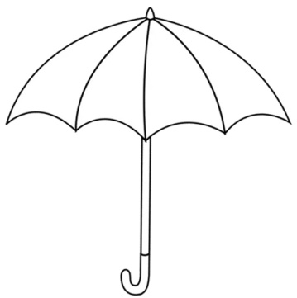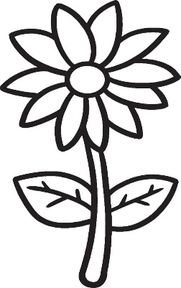

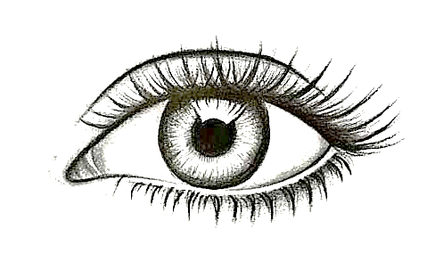

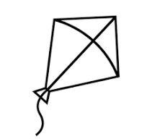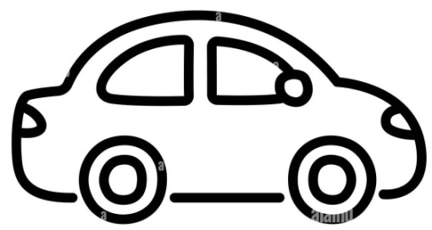

1. Rhymes. [5]
2. Dance. [5]
3. Neat and clean. [10]
4. Regularity. [10]

**The End**